Detection of Possible Illicit Messages Using Natural Language Processing and Computer Vision on Twitter and Linked Websites

In this paper author is describing concept to detect human trafficking by analysing social media text messages with the help of SVM and Naïve Bayes machine learning algorithms. In this paper author first crawling twitter by using words like Lolita, escort and many more and then extracted tweets will go for cleaning to remove special symbols and stop words (words such as the, where, and, an, are etc.) and then tweets will be analyse to extracts words such as VERBS and ADJECTIVE and this words may contains important subjects or suspicious words used by HUMAN TRAFFICKERS (the suspicious words can be chicken soup, girls, penguin and many more. Clean tweets will be given input to SVM and Naïve Bayes classifier to detect suspicious words.

If any tweet contains suspicious words then that tweet website will be scanned for images and each image will be processed through SVM HAARCASCADE classifier to detect face from that image and same algorithm will be used to detect upper body and both resultant images will be input to CNN (Convolution Neural Networks) classifier which will detect or predict AGE and GENDER from the resultant images. In this paper we are detecting gender as MALE and FEMALE and AGE will predicted with two classes as UNDER 14 Years or OVER 14 Years.

Note: To run this project your system must connect to internet to crawl twitter and to scrape websites for image

This project consists of following modules

1. Online Crawl Twitter: In this module we can enter HASHTAG and then application will crawl twitter using TWEEPY API to read all tweets from given hashtag.
2. Offline Upload Twitter Dataset: In this module if you don’t want to crawl twitter then you can upload existing twitter dataset.
3. Clean Tweets & Extract Features: using this module each tweet will be processed to remove special symbols and stop words and then extract VERBS and ADJECTIVES and the clean tweets will be feed to SVM and Naïve Bayes algorithm. In both SVM and Naïve Bayes algorithms SVM is giving better suspicious tweets detection result.
4. Suspicious Tweets Classification using SVM & Naive Bayes: using this module we will input clean tweets to SVM and Naïve Bayes algorithms and then the application will divide entire data into train and test parts where 80% data will be used for training and 20% data will be used for testing. First by using 80% data algorithms will be trained and generate a model. A trained model will be applied on test data to calculate prediction accuracy, precision, recall and FSCORE.
5. SVM & CNN Classification for Gender & age Prediction: After detecting suspicious tweets then each suspicious tweet website will be scan to read all images and then from that image face and upper body part will be extracted using SVM classifier and the resultant images will be input to CNN to predict AGE and GENDER.
6. Comparison Graph: in this module we are displaying comparison graph between SVM and Naïve Bayes in the form of precision, recall and FSCORE.

SCREENSHOTS

To run project double click on ‘run.bat’ file to get below screen

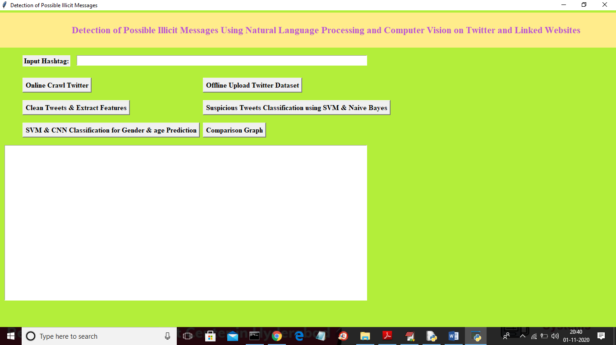

In above screen enter hashtag and then click on ‘Online Crawl Twitter’ button to start crawling.

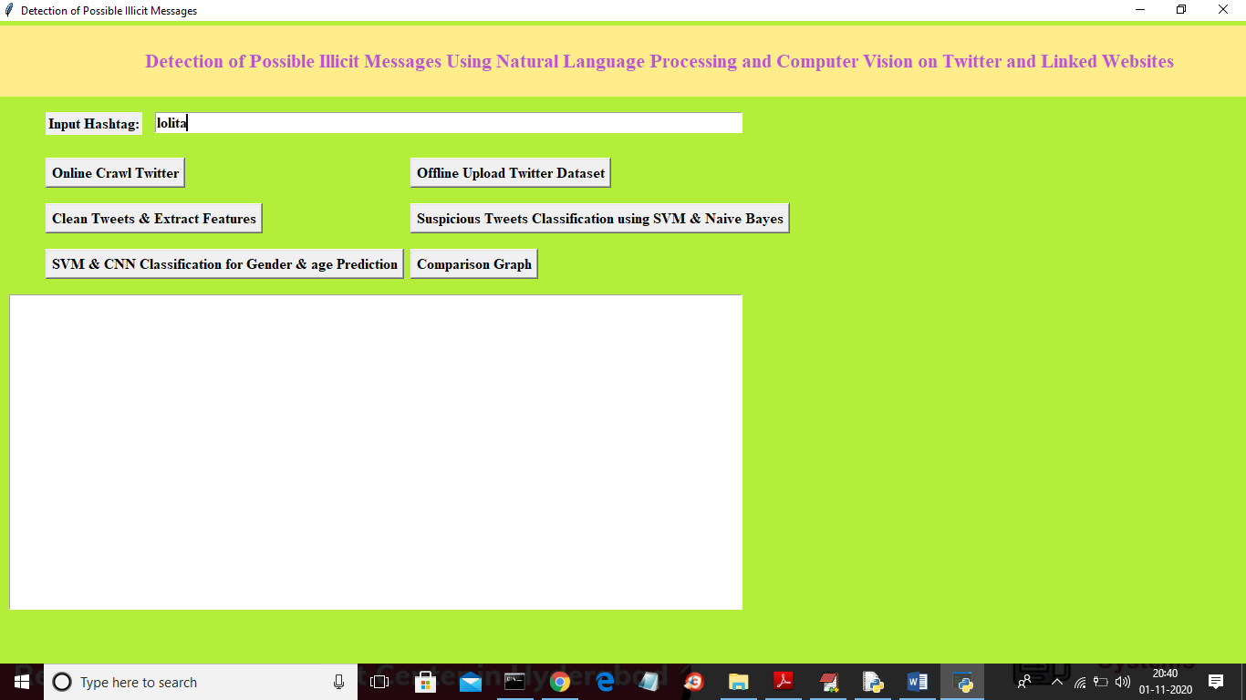

In above screen I entered hashtag as ‘lolita’ and the press ‘Online Crawl Twitter’ button to start crawling. In below black screen we can see crawling started and I am displaying tweet date and tweet text

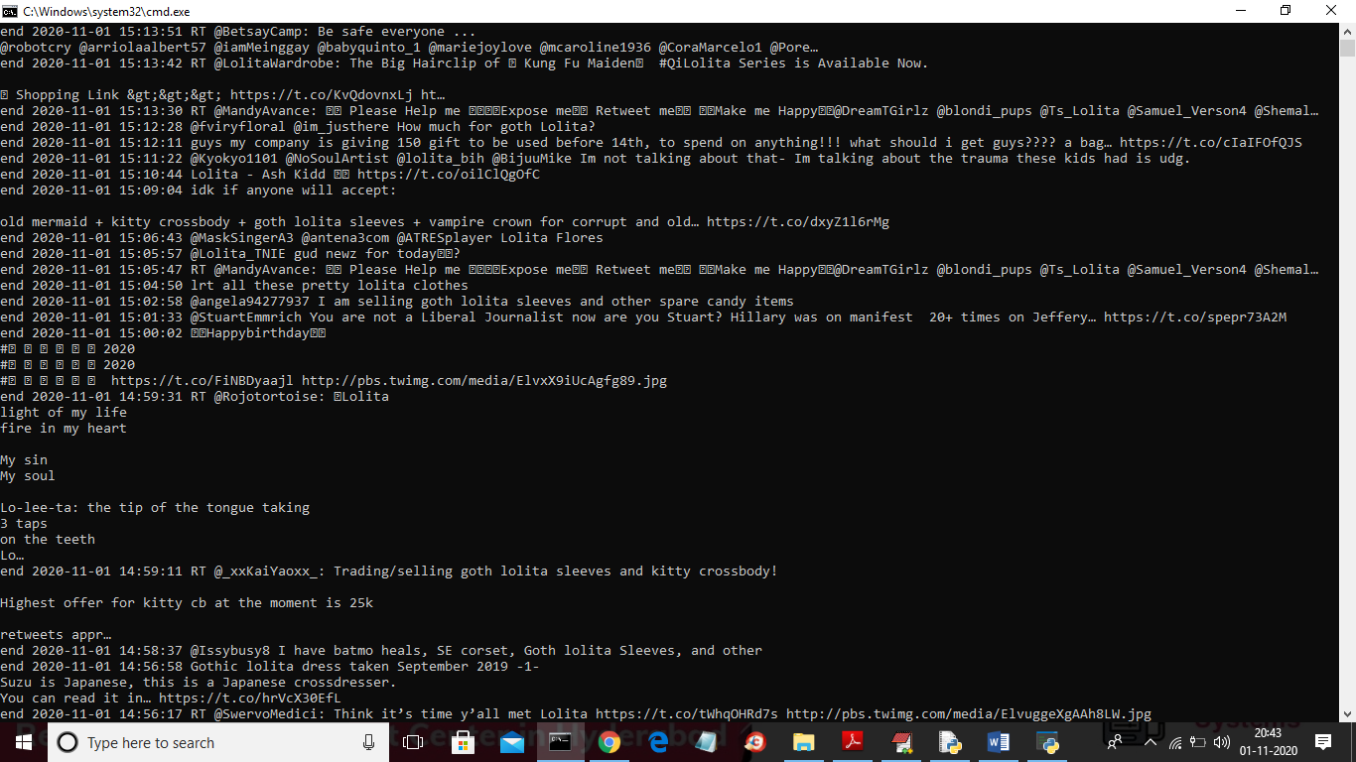

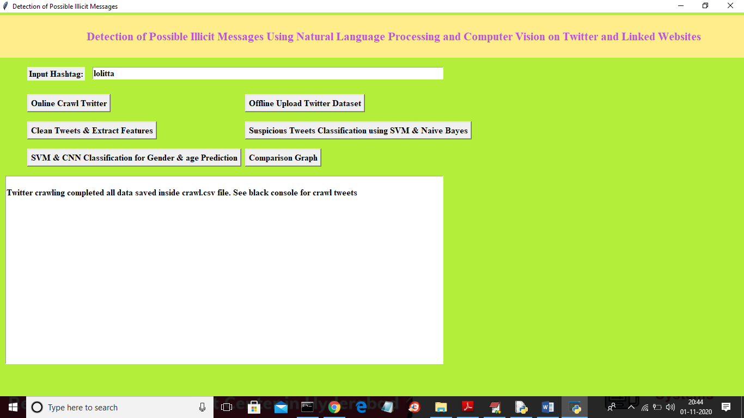

In above screen we can see status message as twitter crawling complete and now click on ‘Clean Tweets & Extract Features

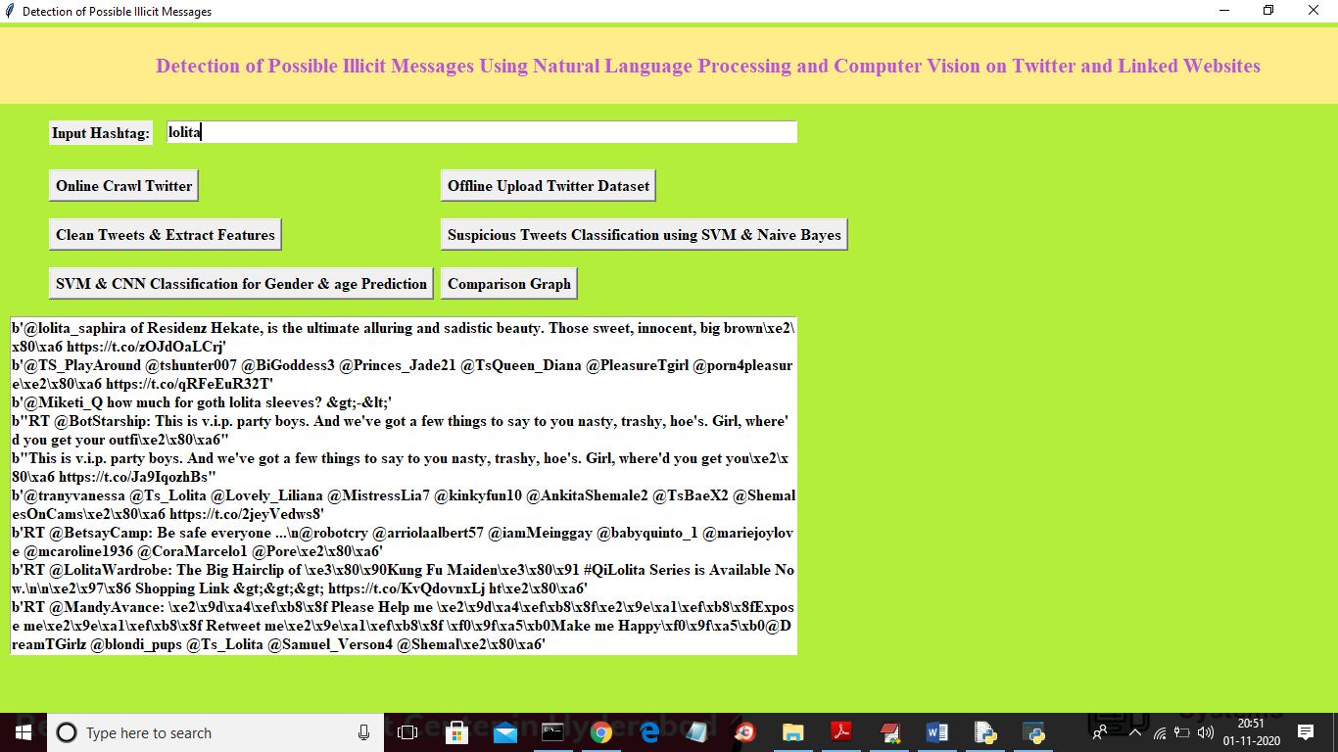

In above screen we can see each raw tweets that get processed for cleaning and now clean tweets are ready and to detect suspicious words click on ‘Suspicious Tweets Classification using SVM & Naive Bayes’ button to apply SVM and Naïve Bayes on each tweet to get suspicious words

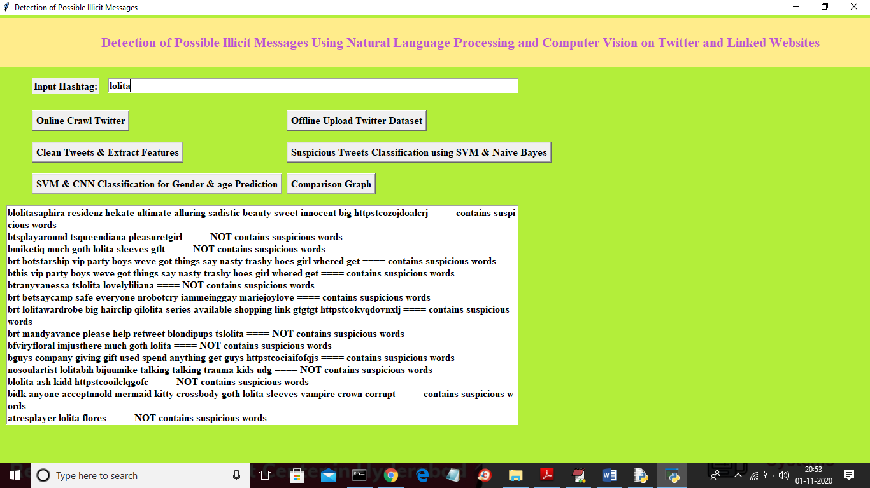

In above screen displaying each cleaned tweets and after equal to symbol displaying detected result as contains suspicious words or not. Now we have tweets which contains suspicious words and now click on ‘SVM & CNN Classification for Gender & age Prediction’ button to scrape each tweets website to read image and the predict AGE and GENDER from images

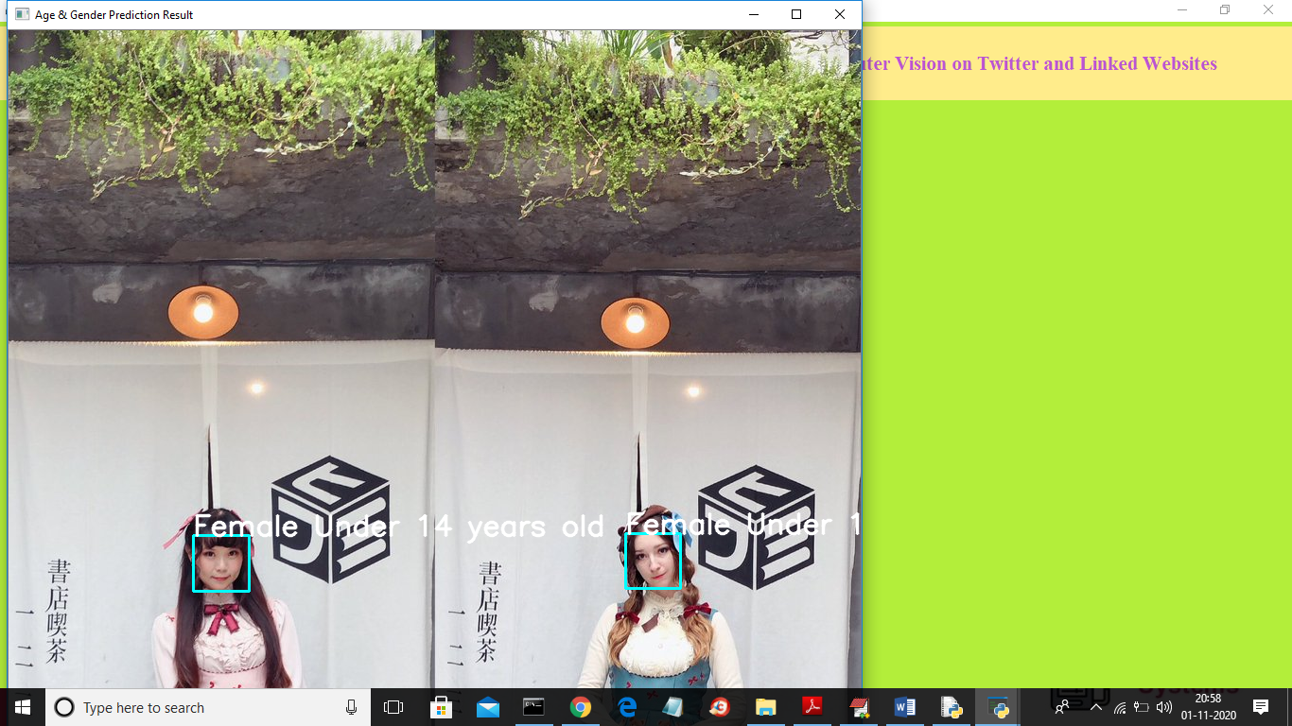

In above screen application detected face and then displaying female under 14 years and application repeats above steps for all tweets and below see another image

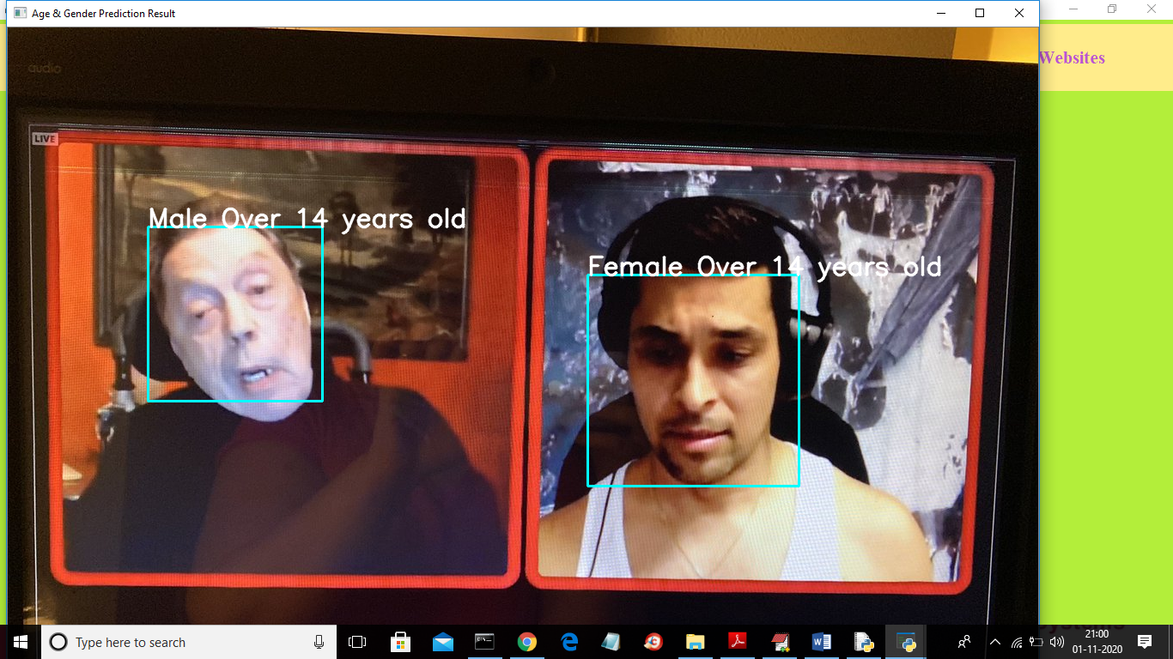

In above screen we can see the result of another image

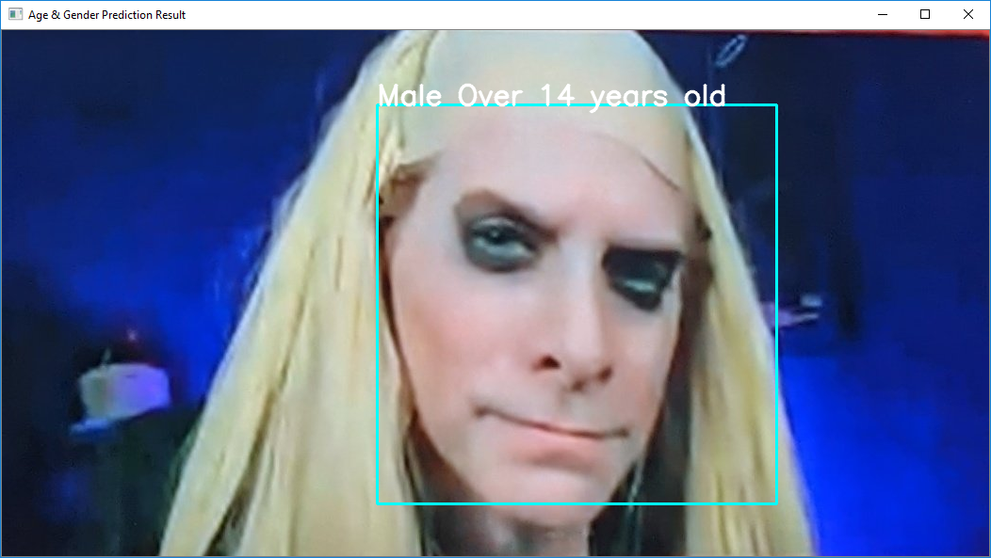

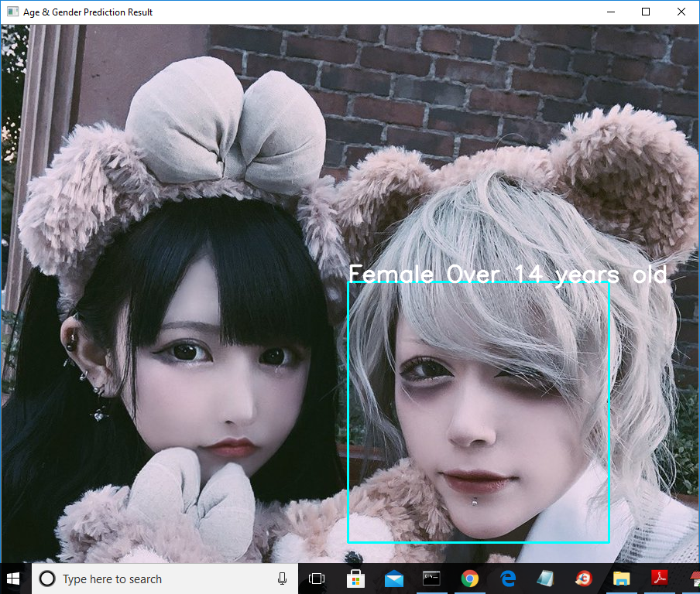

Note: No algorithms are 100% perfect to detect accurate faces and gender and so our algorithms also give 70% correct prediction as I have not trained model with huge number of epoch. We need super computers to train dataset with more than 1000 epochs and will take days of time to trained model. Due to that reason our model will predict 70% correctly.

Now click on ‘Comparison Graph’ button to get below graph

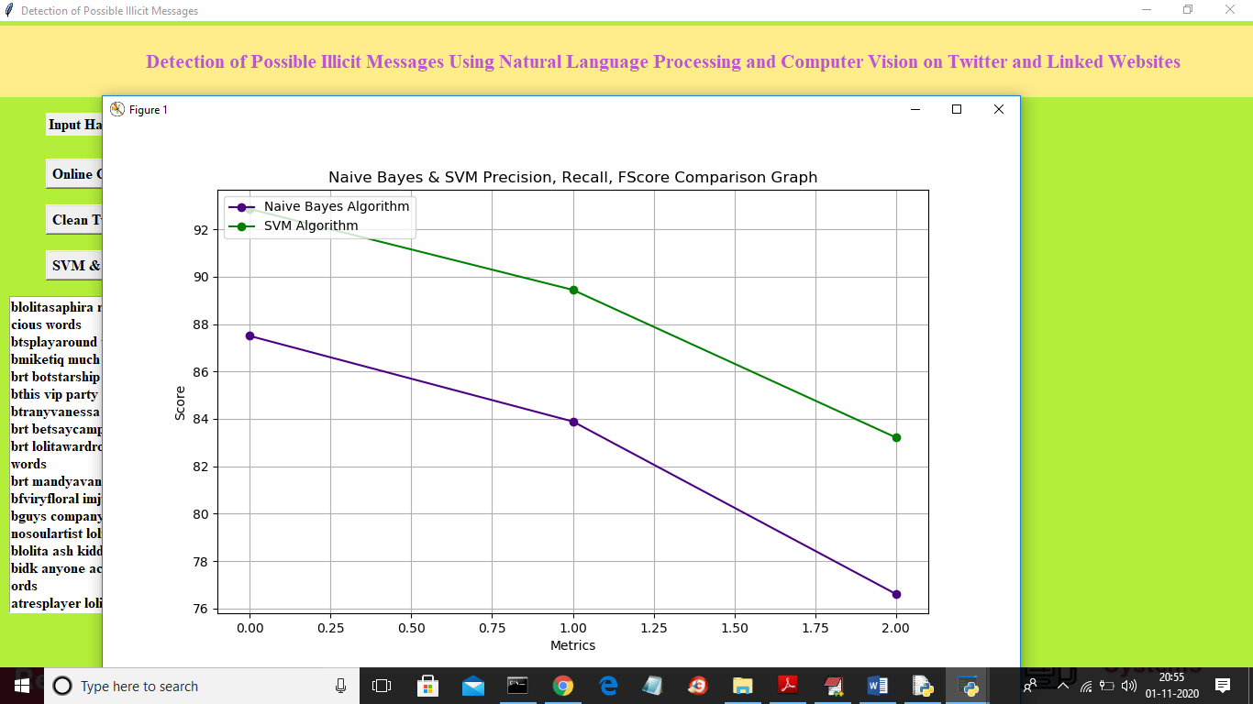

In above graph blue line represents Naïve Bayes precision, recall and FScore and green line represents for SVM. In above graph x-axis contains precision, recall and FScore and y-axis represents its values. From above graph we can conclude that SVM is giving better performance.